A Digital and Coaching Mental Health and Wellbeing Program for At-Risk Youth

Kids at Risk Action, a non-profit organization focused on improving the lives of at-risk youth, and Praestan Health, the company behind PortagesTM, are collaborating to serve youth ages 13-21 who are involved in child welfare and juvenile justice systems. The goal is to provide a targeted early intervention for these at-risk youth and attempt to mitigate the adversity and trauma many have experienced. Although this mental health promotion initiative is not clinical treatment, it will have beneficial impact in building resilience and coping skills in these at-risk youth.

Many of the targeted youth suffer from emotional concerns. These youth can benefit from working with a supportive coach using Portages, a highly engaging and conveniently accessed mental health and wellbeing program. With Portages, youth are guided to change their health behaviors to promote optimal mental health and wellbeing and reduce emotional concerns.

Portages Digital Mental Health and Wellbeing Program

To Portage is to carry your vessel and your gear on a path from one body of water to the next on your journey. Similarly, improving mental health and wellbeing involves moving your mind and body through multiple paths of health behavior change to build new skills and habits. A coach using Portages can guide youth on a personalized journey to make health behavior changes to transform their mental health and wellbeing.

No other digital health program has the features of Portages. The advantage lies in the underlying Portages model of programming, the way technology delivers it, and being able to work with a coach using the same program and platform. Science-based principles and practices are incorporated throughout the Portages digital program.

The Portages Way: The program embodies a highly appealing and strengths-based whole-person model of mental health and wellbeing to organize each individual’s change journey. This includes focusing on:
- 4 Worlds of Living encompassing a whole-person view of wellbeing through Internal, Physical, External and Spiritual Worlds. Portages integrates this global view of wellbeing into each personalized journey to health improvement. See https://www.portages.io/4-world-of-living/
- 12 Health Practices that are the everyday actions, thoughts, and emotions of that influence mental health and wellbeing. There are 3 health practices that align with each of the 4 Worlds of Living that determine wellbeing. Portages guides youth to improve these health practices to enhance mental health and wellbeing. See https://www.portages.io/12-health-practices/
- 8 Readiness Beliefs that are important to successfully changing habits and behaviors. Having a ready mindset helps to prepare to undergo a unique health journey. Portages focuses on readiness so that youth are prepared to engage in improving and maintaining their health practices. See https://www.portages.io/64-readiness-plans/
Digital Program Delivery: The Portages platform, which meets the highest standards of quality, design, and functionality, delivers the whole-person mental health and wellbeing program to youth and assists the coaches who work with them. A Portages app provides scaffolding and guidance for youth to use the program on their own each day in a self-guided manner. In addition, a linked dashboard enables practitioners to coach youth using the same program and platform and allows for remote monitoring of how the youth is using the program and the impact.

Portages Coaching

Youth who have experienced adversity will benefit from working with a trusted and consistent professional providing coaching using the Portages program. This practitioner further guide’s youth on their Portages journey and assists them in accessing and navigating other mental health services as needed. The coach also provides tips for caretakers on how to support the youth in their change journey and coordinates with other professionals if indicated. Coaching occurs virtually to remove access barriers, and use of the Portages platform during visits facilitates the meetings.

Appendix:

Pilot Program Evaluation of Portages for Youth

The effects of Portages was explored in a small observational pilot study, where youth received an earlier web-based version of Portages and coaching by therapists in primary care (n=44). Participating youth completed self-report assessments at pre-test baseline and post-test after 3-6 months of programming. Most youth showed growth in Health Practices related to everyday healthy habits and behaviors (see Figure1). The magnitude of change from pre to post ranged from small to large with the highest growth in areas related to Internal and Spiritual Worlds (see Figure 2). In addition, most youth showed reductions on different indicators of emotional concerns (see Figure 3). The magnitude of change from pre to post ranged from small to large with the highest amount of reduction in Distress and Anxiety (see Figure 4). The preliminary program evaluation results reveal that Portages helps youth change health behaviors to promote optimal mental health and wellbeing and reduce emotional concerns.

Impact on Health Practices Indicators

Figure 1.
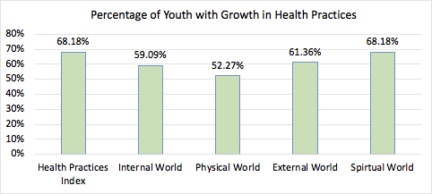

Figure 2.
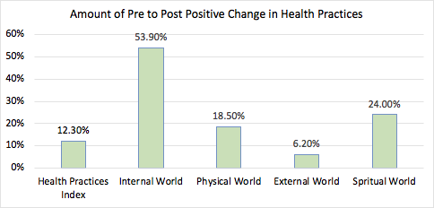

Note:
Health Practices Index: Overall Everyday Habits and Behaviors that Affect Mental Health and Wellbeing
Internal World: Health Practices to Regulate Emotions, Thoughts, and Stress
Physical World: Health Practices to Promote Optimal Physical Health and Boost Mood
External World: Health Practices to Enhance Social Relationships and Productive Behaviors
Spiritual World: Health Practices to Cultivate Contemplation, Purpose and Meaning, and Living According to Beliefs

Impact on Emotional Concerns

Figure 3.
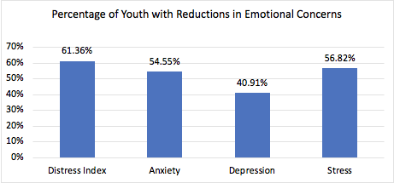

Figure 4.
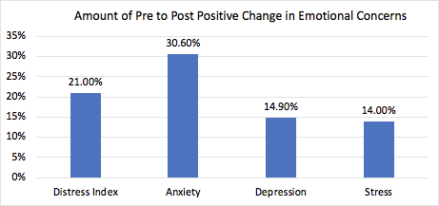

Note:
Distress Index: Overall Feelings of Anguish and Suffering
Anxiety: Feeling Nervous and Worried
Depression: Feeling Down and Dissatisfied
Stress: Feeling Overwhelmed and Struggling to Cope

